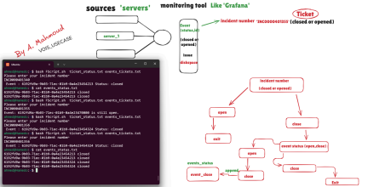
logic outline
.)Read user input (incident number ●
.Search ticket_status for that incident number and get the status ● ."If not found, print "Incident not found ●
:If status is closed ●
.Find event ID from events_tickets.txt ○
.Write event ID and "closed" to events_status.txt ○
.Print event and status to user ○
:If status is opened ●
.Find event ID ○
."Print event and message "Event is still open ○
FScript.sh
Senario in Section Simulate VOIS USECASE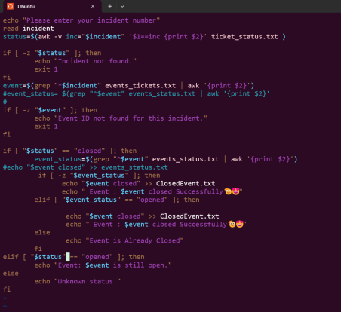
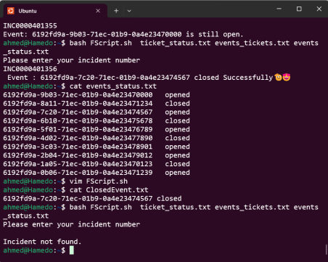in Senario file >>
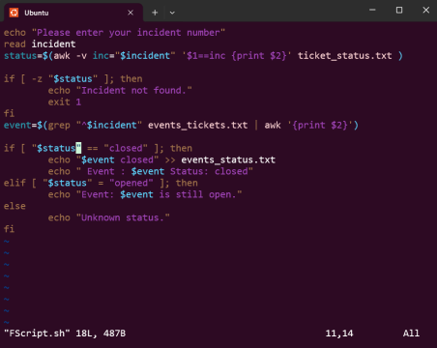Usecase_Test
